

***Capstone Project***

**Report 4**

**Software design description**

*Personal Finance Management*

**Author: PFM Team**

**Supervisor: Mr. Nguyen Van Hien**

**Hanoi, 19­­th Oct, 2012**

**Record of changes:**

|  |  |  |  |  |
| --- | --- | --- | --- | --- |
| Date | Change Item | Description | By | Version |
| 19th Oct, 2012 | First create | Create new document | Locnd | 1.0 |
|  |  |  |  |  |
|  |  |  |  |  |

Table of Contents

I – Overview 3

II – Class diagram 3

1. Schedule function: 3

2. Incomes & expenses management function: 6

III – Sequence diagram 10

1. Schedule function: 10

2. Incomes & expenses management function: 10

# I – Overview

# II – Class diagram

## Schedule function

* 1. 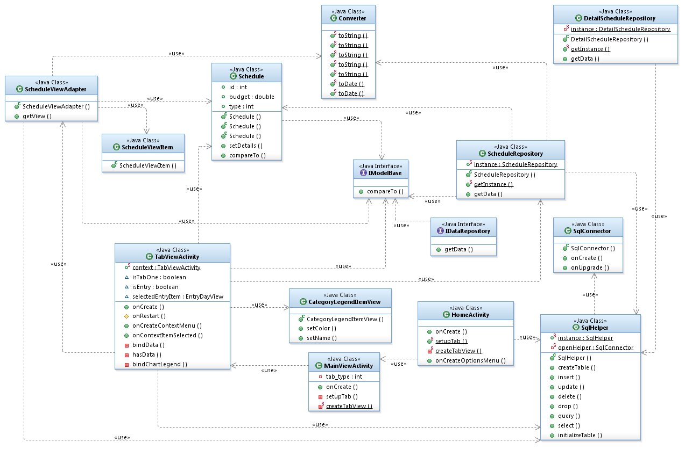Class diagram for Schedule view function:
  2. Class diagram for Schedule edit function:

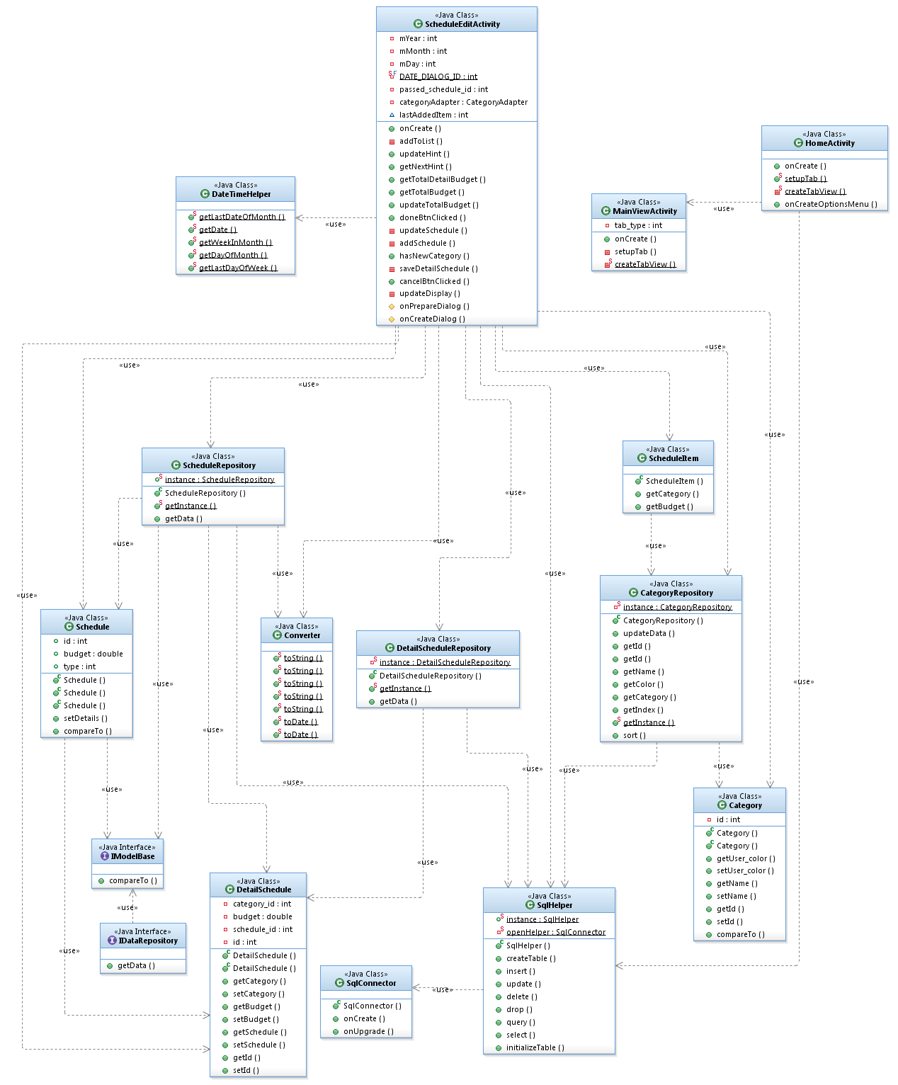

* 1. 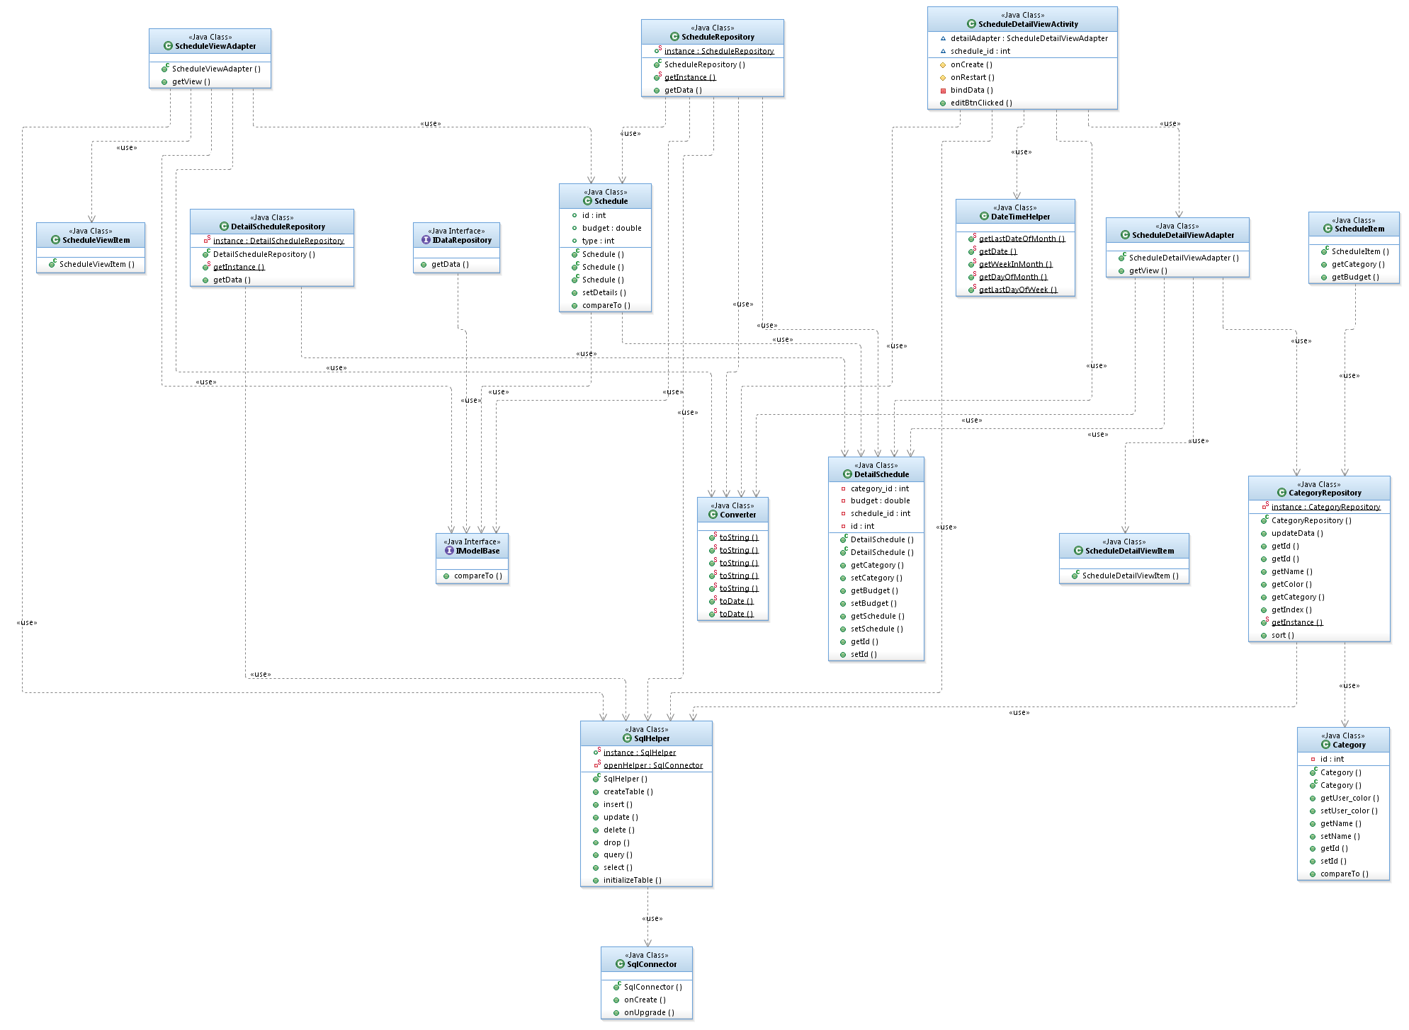Class diagram for detailed Schedule view function:

## Incomes & expenses management function

1. 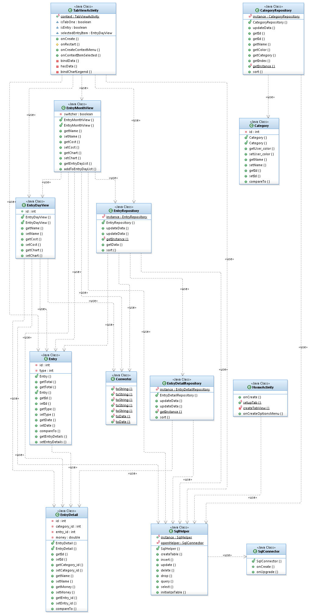Class diagram for incomes and expenses management view:
2. Class diagram for incomes and expenses management edit:

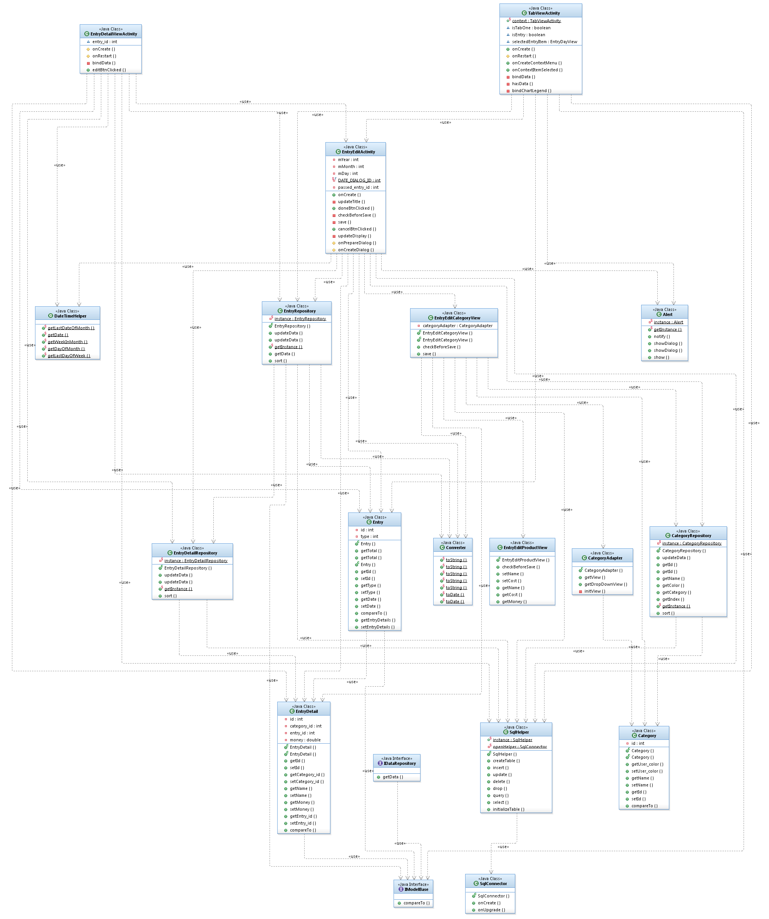

1. Class diagram for detailed incomes and expenses management view:

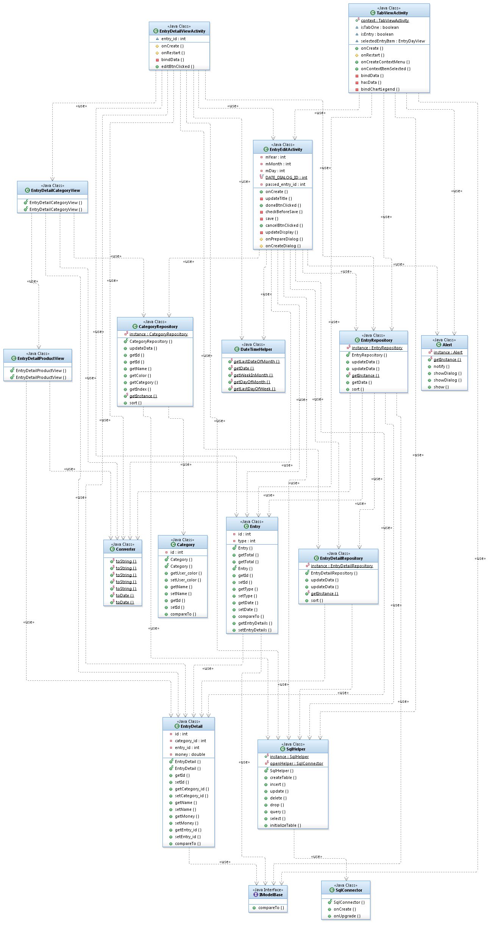

# III – Sequence diagram

## Schedule function

* 1. 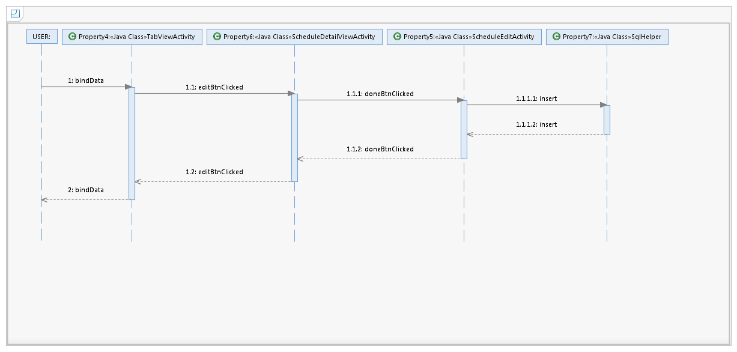Add a schedule:
  2. Edit a schedule:

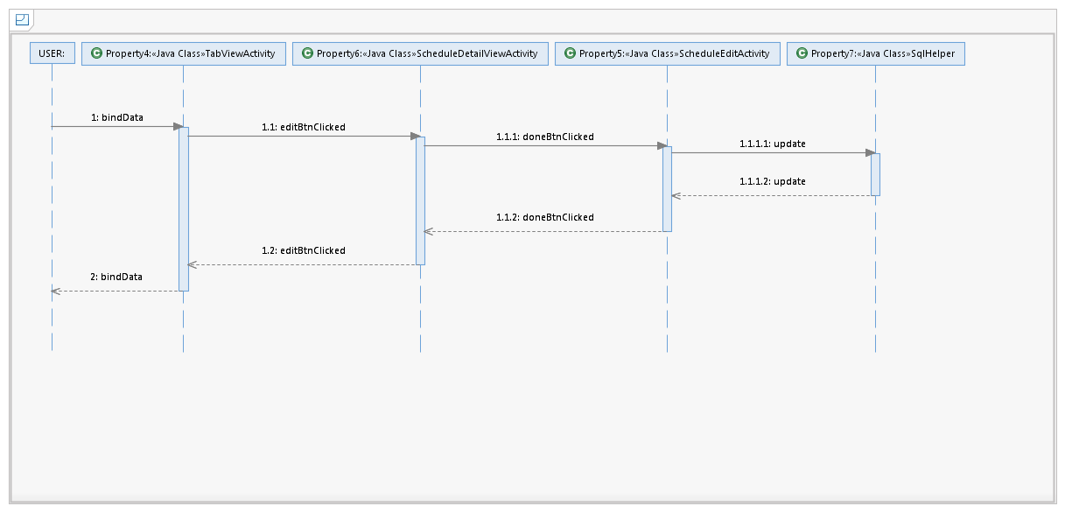

* 1. 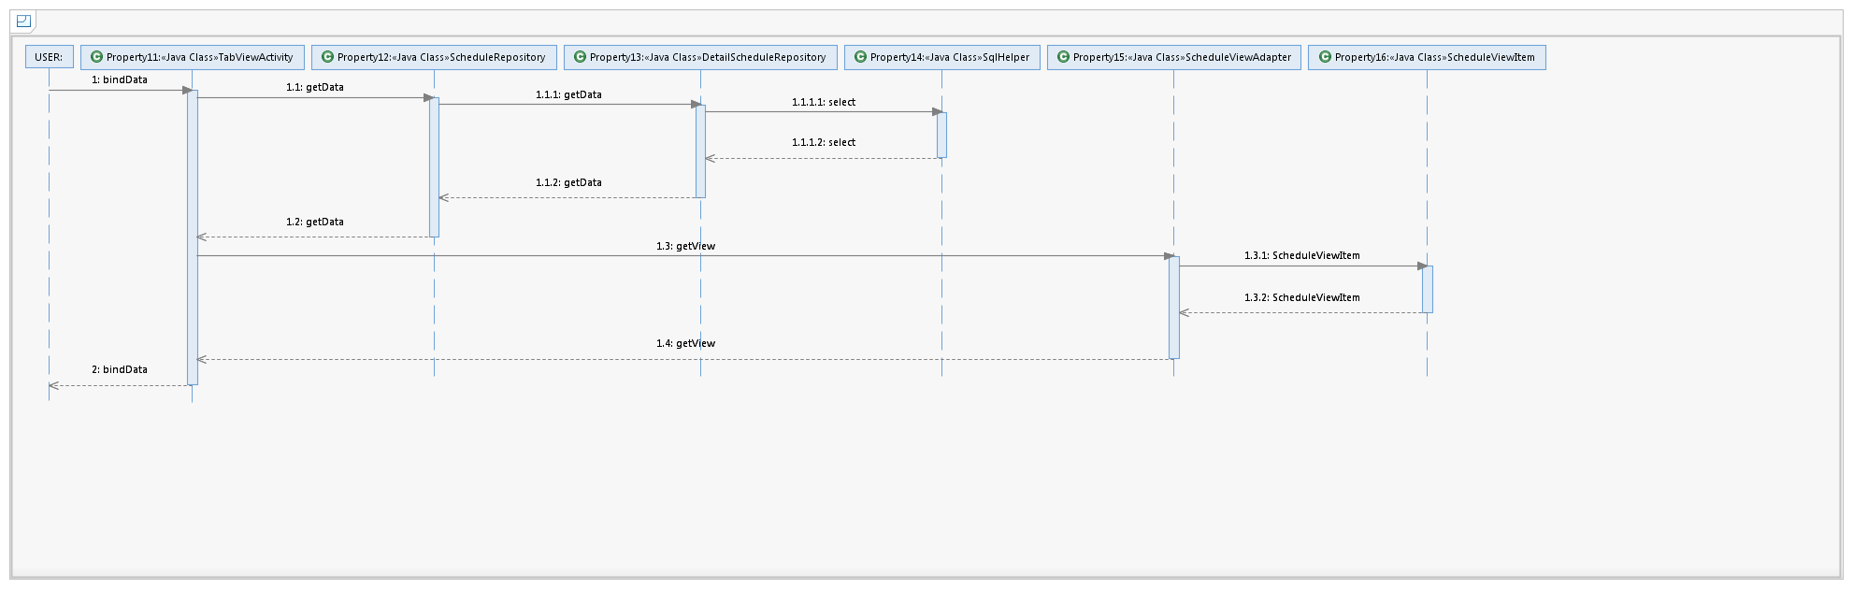View a schedule:
  2. View detailed schedule: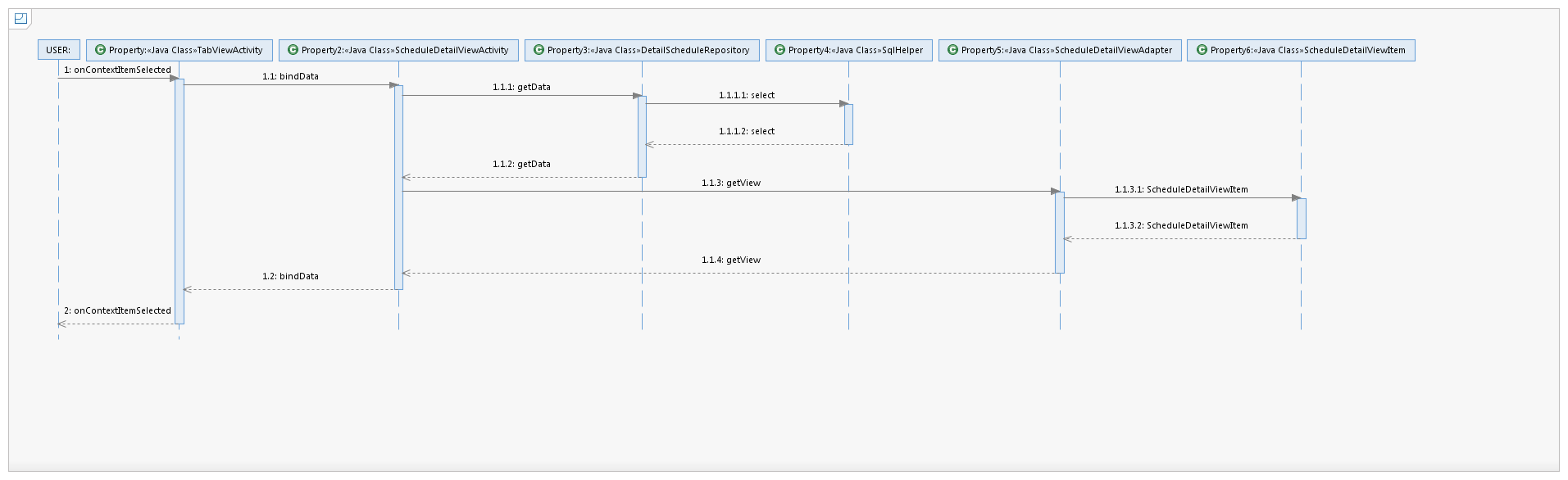

## Incomes & expenses management function

* 1. Add a record:

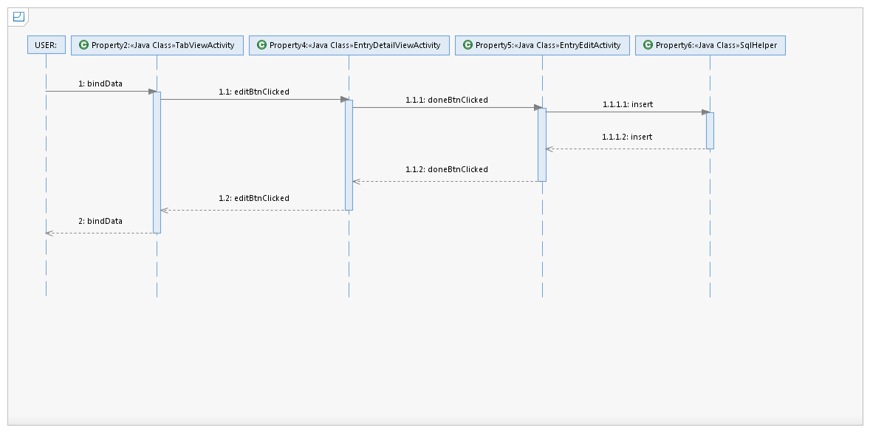

* 1. Edit a record:

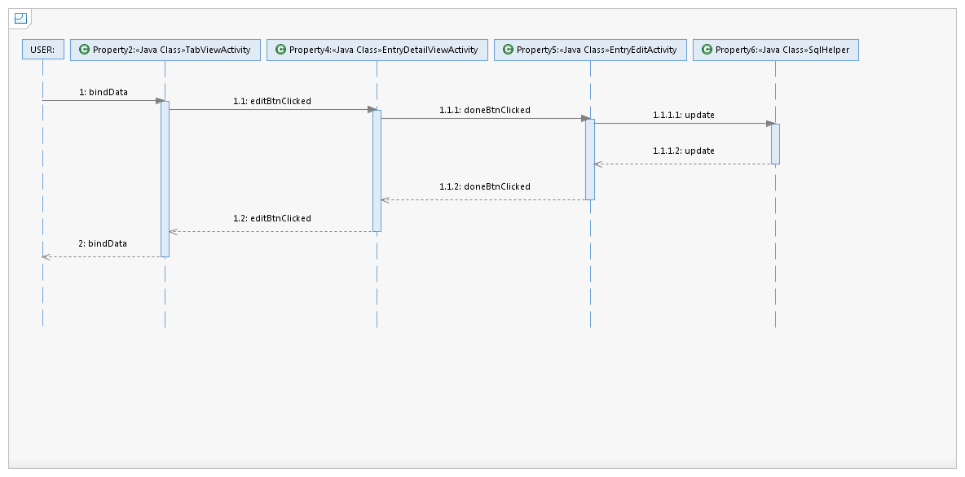

* 1. View a record: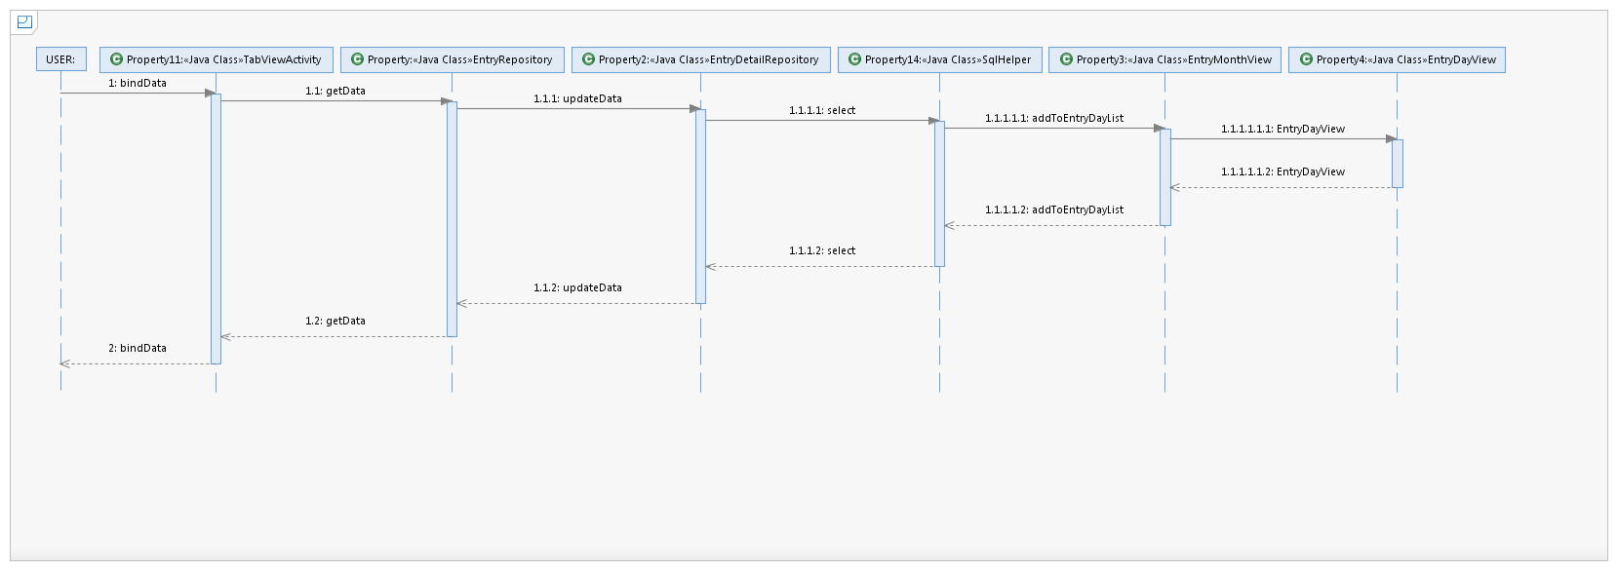
  2. View a detailed record: